**Chapter No 1.**

**What is machine learning?**

Machine learning (ML) is a type of artificial intelligence (AI) that allows software applications to become more accurate at predicting outcomes without being explicitly programmed to do so. Machine learning algorithms use historical data as input to predict new output values.

Example (Handwriting recognition learning problem) Class of task T: recognizing and classifying handwritten words within images. Performance measure P: percent of words correctly classified. Training experience E: a database of handwritten words with given classifications.

Example (Robot driving learning problem) Class of task T: driving a robot on the public highways using vision sensors. Performance measure P: average distance travelled before an error. Training experience E: a sequence of images and steering command recorded.

Why we need machine learning?

We need machine learning because

1. Tasks are too complex to program Tasks performed by animals/humans such as driving, speech recognition, image understanding, and etc. Tasks beyond human capabilities such as weather prediction, analysis of genomic data, web search engines, and etc.

2. Some tasks need adaptivity. When a program has been written down, it stays unchanged. In some tasks such as optical character recognition and speech recognition, we need the behavior to be adapted when new data arrives

**Types of machine learning**

Machine learning algorithms based on the information provided to the learner can be classified into three main groups.

1. **Supervised/predictive learning:** The goal is to learn a mapping from inputs x to outputs y given the labeled set S = {(x1,t1),(x2,t2), . . . ,(xN ,tN )}. xk is called feature vector. When ti ∈ {1, 2, . . . , C}, the learning problem is called classification. When ti ∈ R, the problem is called regression.

2. **Unsupervised/descriptive learning:** The goal is to find interesting pattern in data S = {x1, x2, . . . , xN }. Unsupervised learning is arguably more typical of human and animal learning. 3. Reinforcement learning: Reinforcement learning is learning by interacting with an environment. A reinforcement learning agent learns from the consequences of its actions.

**Applications of machine learning**

1. **Supervised learning**: Classification: Document classification and spam filtering. Image classification and handwritten recognition. Face detection and recognition. Regression: Predict stock market price. Predict temperature of a location. Predict the amount of PSA.

2. **Unsupervised/descriptive learning:** Discovering clusters. Discovering latent factors. Discovering graph structures (correlation of variables). Matrix completion (filling missing values). Collaborative filtering. Market-basket analysis (frequent item-set mining).

3. **Reinforcement learning:** Game playing. robot navigation

**Best Python libraries for Machine Learning**

Today, Python is one of the most popular programming languages for this task and it has replaced many languages in the industry, one of the reasons is its vast collection of libraries. Python libraries that are used in Machine Learning are: 

* Numpy
* Scipy
* Scikit-learn
* Theano
* TensorFlow
* Keras
* PyTorch
* Pandas
* Matplotlib

**Numpy :** NumPy is a very popular python library for large multi-dimensional array and matrix processing, with the help of a large collection of high-level mathematical functions. It is very useful for fundamental scientific computations in Machine Learning. It is particularly useful for linear algebra, Fourier transform, and random number capabilities. High-end libraries like TensorFlow uses NumPy internally for manipulation of Tensors.

**Scipy :** SciPy is a very popular library among Machine Learning enthusiasts as it contains different modules for optimization, linear algebra, integration and statistics. There is a difference between the SciPy library and the SciPy stack. The SciPy is one of the core packages that make up the SciPy stack. SciPy is also very useful for image manipulation.

**Scikit-learn :** Scikit-learn is one of the most popular ML libraries for classical ML algorithms. It is built on top of two basic Python libraries, viz., NumPy and SciPy. Scikit-learn supports most of the supervised and unsupervised learning algorithms. Scikit-learn can also be used for data-mining and data-analysis, which makes it a great tool who is starting out with ML.

**Theano :** We all know that Machine Learning is basically mathematics and statistics. Theano is a popular python library that is used to define, evaluate and optimize mathematical expressions involving multi-dimensional arrays in an efficient manner. It is achieved by optimizing the utilization of CPU and GPU. It is extensively used for unit-testing and self-verification to detect and diagnose different types of errors. Theano is a very powerful library that has been used in large-scale computationally intensive scientific projects for a long time but is simple and approachable enough to be used by individuals for their own projects.

**TensorFlow :** TensorFlow is a very popular open-source library for high performance numerical computation developed by the Google Brain team in Google. As the name suggests, Tensorflow is a framework that involves defining and running computations involving tensors. It can train and run deep neural networks that can be used to develop several AI applications. TensorFlow is widely used in the field of deep learning research and application.

**Keras :** Keras is a very popular Machine Learning library for Python. It is a high-level neural networks API capable of running on top of TensorFlow, CNTK, or Theano. It can run seamlessly on both CPU and GPU. Keras makes it really for ML beginners to build and design a Neural Network. One of the best thing about Keras is that it allows for easy and fast prototyping.

**PyTorch :** PyTorch is a popular open-source Machine Learning library for Python based on Torch, which is an open-source Machine Learning library that is implemented in C with a wrapper in Lua. It has an extensive choice of tools and libraries that support Computer Vision, Natural Language Processing(NLP), and many more ML programs. It allows developers to perform computations on Tensors with GPU acceleration and also helps in creating computational graphs.

**Pandas :** Pandas is a popular Python library for data analysis. It is not directly related to Machine Learning. As we know that the dataset must be prepared before training. In this case, Pandas comes handy as it was developed specifically for data extraction and preparation. It provides high-level data structures and wide variety tools for data analysis. It provides many inbuilt methods for grouping, combining and filtering data.

**Matplotlib :** Matplotlib is a very popular Python library for data visualization. Like Pandas, it is not directly related to Machine Learning. It particularly comes in handy when a programmer wants to visualize the patterns in the data. It is a 2D plotting library used for creating 2D graphs and plots. A module named pyplot makes it easy for programmers for plotting as it provides features to control line styles, font properties, formatting axes, etc. It provides various kinds of graphs and plots for data visualization, viz., histogram, error charts, bar chats, etc,

**What is Artificial Intelligence?**

Artificial intelligence (AI), sometimes called machine intelligence, is intelligence demonstrated by machines, in contrast to the natural intelligence displayed by humans and other animals, such as "learning" and "problem solving.

Artificial Intelligence is a way of making a computer, a computer-controlled robot, or a software think intelligently, in the similar manner the intelligent humans think.

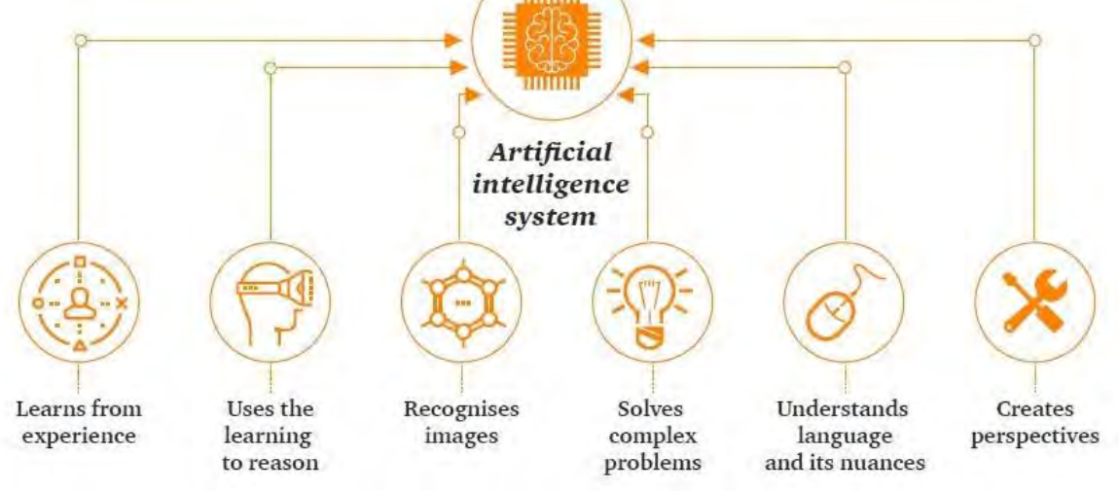

## **What is Machine Learning?**

Machine Learning is a branch of artificial intelligence that develops algorithms by learning the hidden patterns of the datasets used it to make predictions on new similar type data, without being explicitly programmed for each task.

Traditional Machine Learning combines data with statistical tools to predict an output that can be used to make actionable insights.

Machine learning is used in many different applications, from image and speech recognition to natural language processing, recommendation systems, fraud detection, portfolio optimization, automated task, and so on.

Machine learning models are also used to power autonomous vehicles, drones, and robots, making them more intelligent and adaptable to changing environments.

## **Differences between AI and ML**

| **Sr.No.** | **ARTIFICIAL INTELLIGENCE** | **MACHINE LEARNING** |
| --- | --- | --- |
| 1. | 1956 The terminology “Artificial Intelligence” was originally used by John McCarthy, who also hosted the first AI conference. | The terminology “Machine Learning” was first used in 1952 by IBM computer scientist Arthur Samuel, a pioneer in artificial intelligence and computer games. |
| 2. | AI stands for Artificial intelligence, where intelligence is defined as the  ability to acquire and apply knowledge. | ML stands for Machine Learning which is defined as the  acquisition of knowledge or skill |
| 3. | AI is the broader family consisting of ML and DL as its components. | Machine Learning is the subset of Artificial Intelligence. |
| 4. | The aim is to increase the chance of success and not accuracy. | The aim is to increase accuracy, but it does not care about; the success |
| 5. | AI is aiming to develop an intelligent system capable of  performing a variety of complex jobs. decision-making | Machine learning is attempting to construct machines that  can only accomplish the jobs for which they have been trained. |
| 6. | It works as a computer program that does smart work. | Here, the tasks systems machine takes data and learns from data. |
| 7. | The goal is to simulate natural intelligence to solve complex problems. | The goal is to learn from data on certain tasks to maximize the  performance on that task. |
| 8. | AI has a very broad variety of applications. | The scope of machine learning is constrained. |
| 9. | AI is decision-making. | ML allows systems to learn new things from data. |
| 10. | It is developing a system that mimics humans to solve problems. | It involves creating self-learning algorithms. |
| 11. | AI will go for finding the optimal solution. | ML will go for a solution whether it is optimal or not. |
| 12. | AI leads to intelligence or wisdom. | ML leads to knowledge. |
| 13. | AI is a broader family consisting of ML and DL as its components. | ML is a subset of AI. |
| 14. | Three broad categories of AI are :   1. Artificial Narrow Intelligence (ANI) 2. Artificial General Intelligence (AGI) 3. Artificial Super Intelligence (ASI) | Three broad categories of ML are :   1. Supervised Learning 2. Unsupervised Learning 3. Reinforcement Learning |
| 15. | AI can work with structured, semi-structured, and unstructured data. | ML can work with only structured and semi-structured data. |
| 16. | AI’s key uses include-   * Siri, customer service via chatbots * Expert Systems * Machine Translation like Google Translate * Intelligent humanoid robots such as Sophia,  and so on. | The most common uses of machine learning-   * Facebook’s automatic friend suggestions * Google’s search algorithms * Banking fraud analysis * Stock price forecast * Online recommender systems, and so on. |
| 17. | AI refers to the broad field of creating machines that can simulate human intelligence and perform tasks such as understanding natural language, recognizing images and sounds, making decisions, and solving complex problems. | ML is a subset of AI that involves training algorithms on data to make predictions, decisions, and recommendations. |
| 18. | AI is a broad concept that includes various methods for creating intelligent machines, including rule-based systems, expert systems, and machine learning algorithms. AI systems can be programmed to follow specific rules, make logical inferences, or learn from data using ML. | focuses on teaching machines how to learn from data without being explicitly programmed, using algorithms such as neural networks, decision trees, and clustering. |
| 19. | AI systems can be built using both structured and unstructured data, including text, images, video, and audio. AI algorithms can work with data in a variety of formats, and they can analyze and process data to extract meaningful insights. | In contrast, ML algorithms require large amounts of structured data to learn and improve their performance. The quality and quantity of the data used to train ML algorithms are critical factors in determining the accuracy and effectiveness of the system. |
| 20. | AI is a broader concept that encompasses many different applications, including robotics, natural language processing, speech recognition, and autonomous vehicles. AI systems can be used to solve complex problems in various fields, such as healthcare, finance, and transportation. | ML, on the other hand, is primarily used for pattern recognition, predictive modeling, and decision making in fields such as marketing, fraud detection, and credit scoring. |

**Agents in Artificial Intelligence**

**What Is an Agent in AI?**

Okay, did anyone, upon hearing the term “intelligent agent,” immediately picture a well-educated spy with a high IQ? No? Anyway, in the context of the [AI field,](https://www.simplilearn.com/time-to-learn-artificial-intelligence-ai-article) an “agent” is an independent program or entity that interacts with its environment by perceiving its surroundings via sensors, then acting through actuators or effectors.

Agents use their actuators to run through a cycle of perception, thought, and action. Examples of agents in general terms include:

* Software: This Agent has file contents, keystrokes, and received network packages that function as sensory input, then act on those inputs, displaying the output on a screen.
* Human: Yes, we’re all agents. Humans have eyes, ears, and other organs that act as sensors, and hands, legs, mouths, and other body parts act as actuators.
* Robotic: Robotic agents have cameras and infrared range finders that act as sensors, and various servos and motors perform as actuators.

Intelligent agents in AI are autonomous entities that act upon an environment using sensors and actuators to achieve their goals. In addition, intelligent agents may learn from the environment to achieve those goals. Driverless cars and the Siri virtual assistant are examples of intelligent agents in AI.

These are the main four rules all AI agents must adhere to:

* Rule 1: An AI agent must be able to perceive the environment.
* Rule 2: The environmental observations must be used to make decisions.
* Rule 3: The decisions should result in action.
* Rule 4: The action taken by the AI agent must be a rational. Rational actions are actions that maximize performance and yield the best positive outcome.

**The Functions of an Artificial Intelligence Agent**

Artificial Intelligence agents perform these functions continuously:

* Perceiving dynamic conditions in the environment
* Acting to affect conditions in the environment
* Using reasoning to interpret perceptions
* Problem-solving
* Drawing inferences
* Determining actions and their outcomes

**The Number and Types of Agents in Artificial Intelligence**

There are five different types of intelligent agents used in AI. They are defined by their range of capabilities and intelligence level:

**Reflex Agents:** These agents work here and now and ignore the past. They respond using the event-condition-action rule. The ECA rule applies when a user initiates an event, and the Agent turns to a list of pre-set conditions and rules, resulting in pre-programmed outcomes.

**Model-based Agents:** These agents choose their actions like reflex agents do, but they have a better comprehensive view of the environment. An environmental model is programmed into the internal system, incorporating into the Agent's history.

**Goal-based agents:** These agents build on the information that a model-based agent stores by augmenting it with goal information or data regarding desirable outcomes and situations.

**Utility-based agents:** These are comparable to the goal-based agents, except they offer an extra utility measurement. This measurement rates each possible scenario based on the desired result and selects the action that maximizes the outcome. Rating criteria examples include variables such as success probability or the number of resources required.

**Learning agents**: These agents employ an additional learning element to gradually improve and become more knowledgeable over time about an environment. The learning element uses feedback to decide how the performance elements should be gradually changed to show improvement.

**The Structure of Agents in Artificial Intelligence**

Agents in Artificial Intelligence follow this simple structural formula:

**Architecture + Agent Program = Agent**

These are the terms most associated with agent structure:

**Architecture:** This is the machinery or platform that executes the agent.

**Agent Function:** The agent function maps a precept to the Action, represented by the following formula: f:P* - A

**Agent Program:** The agent program is an implementation of the agent function. The agent program produces function f by executing on the physical architecture.

Many AI Agents use the PEAS model in their structure. PEAS is an acronym for Performance Measure, Environment, Actuators, and Sensors. For instance, take a vacuum cleaner.

* **Performance:** Cleanliness and efficiency
* **Environment:** Rug, hardwood floor, living room
* **Actuator**: Brushes, wheels, vacuum bag
* **Sensors:** Dirt detection sensor, bump sensor

Here’s a diagram that illustrates the structure of a utility-based agent,

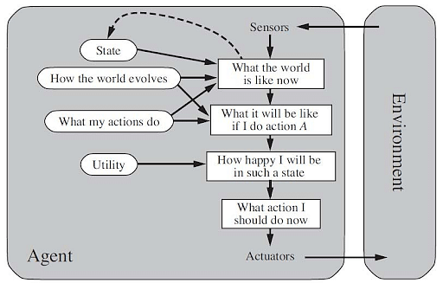

**What Are Agents in Artificial Intelligence Composed Of?**

Agents in Artificial Intelligence contain the following properties:

* Enrironment
* Autonomous
* Flexibility
* Reactive
* Proactiveness
* Using Response Rules

Now, let's discuss these in detail.

### Environment

The agent is situated in a given environment.

### Autonomous

The agent can operate without direct human intervention or other software methods. It controls its activities and internal environment. The agent independently which steps it will take in its current condition to achieve the best improvements. The agent achieves autonomy if its performance is measured by its experiences in the context of learning and adapting.

### Flexibility

* Reactive: Agents must recognize their surroundings and react to the changes within them.
* Proactive: Agents shouldn’t only act in response to their surroundings but also be able to take the initiative when appropriate and effect an opportunistic, goal-directed performance.
* Social: Agents should work with humans or other non-human agents.

### Reactive

* Reactive systems maintain ongoing interactions with their environment, responding to its changes.
* The program’s environment may be guaranteed, not concerned about its success or failure.
* Most environments are dynamic, meaning that things are constantly in a state of change, and information is incomplete.
* Programs must make provisions for the possibility of failure.

### Pro-Activeness

Taking the initiative to create goals and try to meet them.

### Using Response Rules

The goal for the agent is directed behavior, having it do things for the user.

* Mobility: The agent must have the ability to actuate around a system.
* Veracity: If an agent’s information is false, it will not communicate.
* Benevolence: Agents don’t have contradictory or conflicting goals. Therefore, every Agent will always try to do what it is asked.
* Rationality: The agent will perform to accomplish its goals and not work in a way that opposes or blocks them.
* Learning: An agent must be able to learn.